# Lando Drupal 8 (Druppio distribution) Recipe

1. Download and install Lando from <https://github.com/lando/lando/releases> (just pick the .dmg file for the latest version)
2. Personally, I have an /apps folder where I put all of my sites, but up to you what you do (I’ll write the paths below as if it was all sitting inside an /apps directory though)
3. Create a new folder under /apps called ‘druppio’
4. Inside /apps/drupio create a ‘.lando.yml’ file which should contain this:

name: druppio

recipe: drupal8

config:

webroot: drupal8/web

1. Create the ‘apps’ and ‘drupal8’ directories so that you have the structure /apps/druppio/drupal8/web
2. Download the Druppio distribution from <https://www.drupal.org/project/druppio_small_business_distribution> and copy it into the /apps/druppio/drupal8/web directory so that you have (for example) /apps/druppio/drupal8/web/core
3. Move to the top level of your Druppio directory:

cd /apps/druppio

1. Now start lando:

lando start

1. You should now be given a URL that you can navigate to in your browser (mine was [http://druppio.lndo.site](http://druppio.lndo.site/) )
2. Now just follow through the install steps, when you get to the part where you need a database, you can find the connection details by typing ‘lando info’ at your top level Druppio directory:

cd /apps/drupio

lando info

Look carefully through the output to find the database ‘internal_connection’ which should look something like this:

internal_connection: {

host: 'database',

port: '3306'

},

And you will also see the ‘creds’ section which should look like this:

creds: {

database: 'drupal8',

password: 'drupal8',

user: 'drupal8'

},

1. You can now enter these details into the Drupal install, you’ll need to click the ‘Advanced Options’ to open up the part where you can change the ‘Host’ from ‘localhost’ to ’database’ (to match the host shown in the details above). My install screen looks like this:

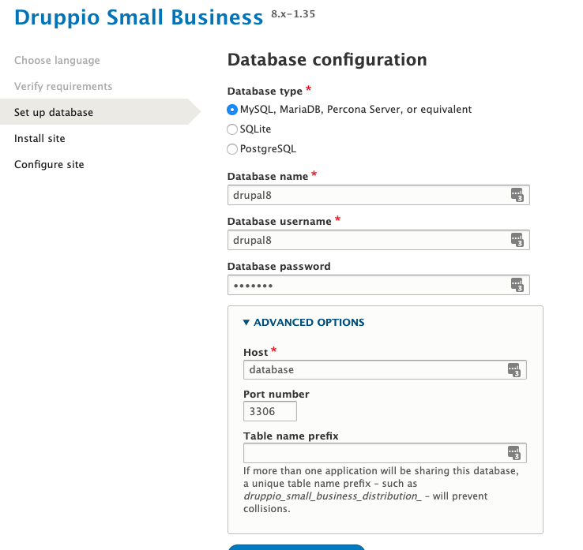

1. That’s it ! Druppio should now be installed and you should see a nice homepage at [http://druppio.lndo.site](http://druppio.lndo.site/) (or whatever your URL is)
2. Have a look around and see what you think. It is worth viewing the site whilst not logged in (or in incognito mode) as well
3. As far as Lando is concerned, you could have a quick look at the docs. Important commands are listed at <https://docs.devwithlando.io/cli/usage.html> but in summary, just type ‘lando stop’ when you want to stop running your Docker container (virtual machine) and maybe type ‘lando restart’ if things suddenly stop working !